

Name: R.Rachitha
Reg.no : 192421058
EXPERIMENT 27
CODE:
import cv2
face = cv2.CascadeClassifier(cv2.data.haarcascades + "haarcascade_frontalface_default.xml")
img = cv2.imread("sample.jpg")
gray = cv2.cvtColor(img, cv2.COLOR_BGR2GRAY)
faces = face.detectMultiScale(gray, 1.3, 5)
for (x,y,w,h) in faces:
cv2.rectangle(img,(x,y),(x+w,y+h),(255,0,0),2)

cv2.imshow("Face Detection", img)
cv2.waitKey(0)
cv2.destroyAllWindows()
Output:
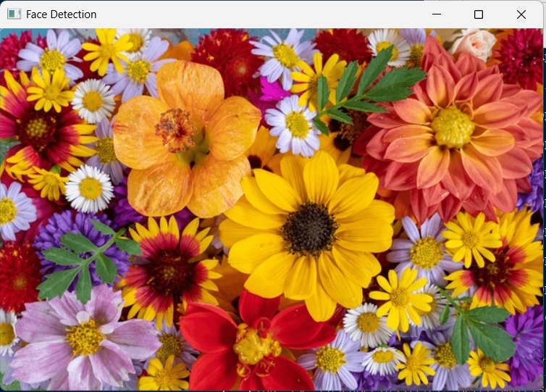
There is no face detected

